# Unit test Result for NHS HR management Application

## Swagger

Link: <http://localhost:8080/swagger-ui.html#/>

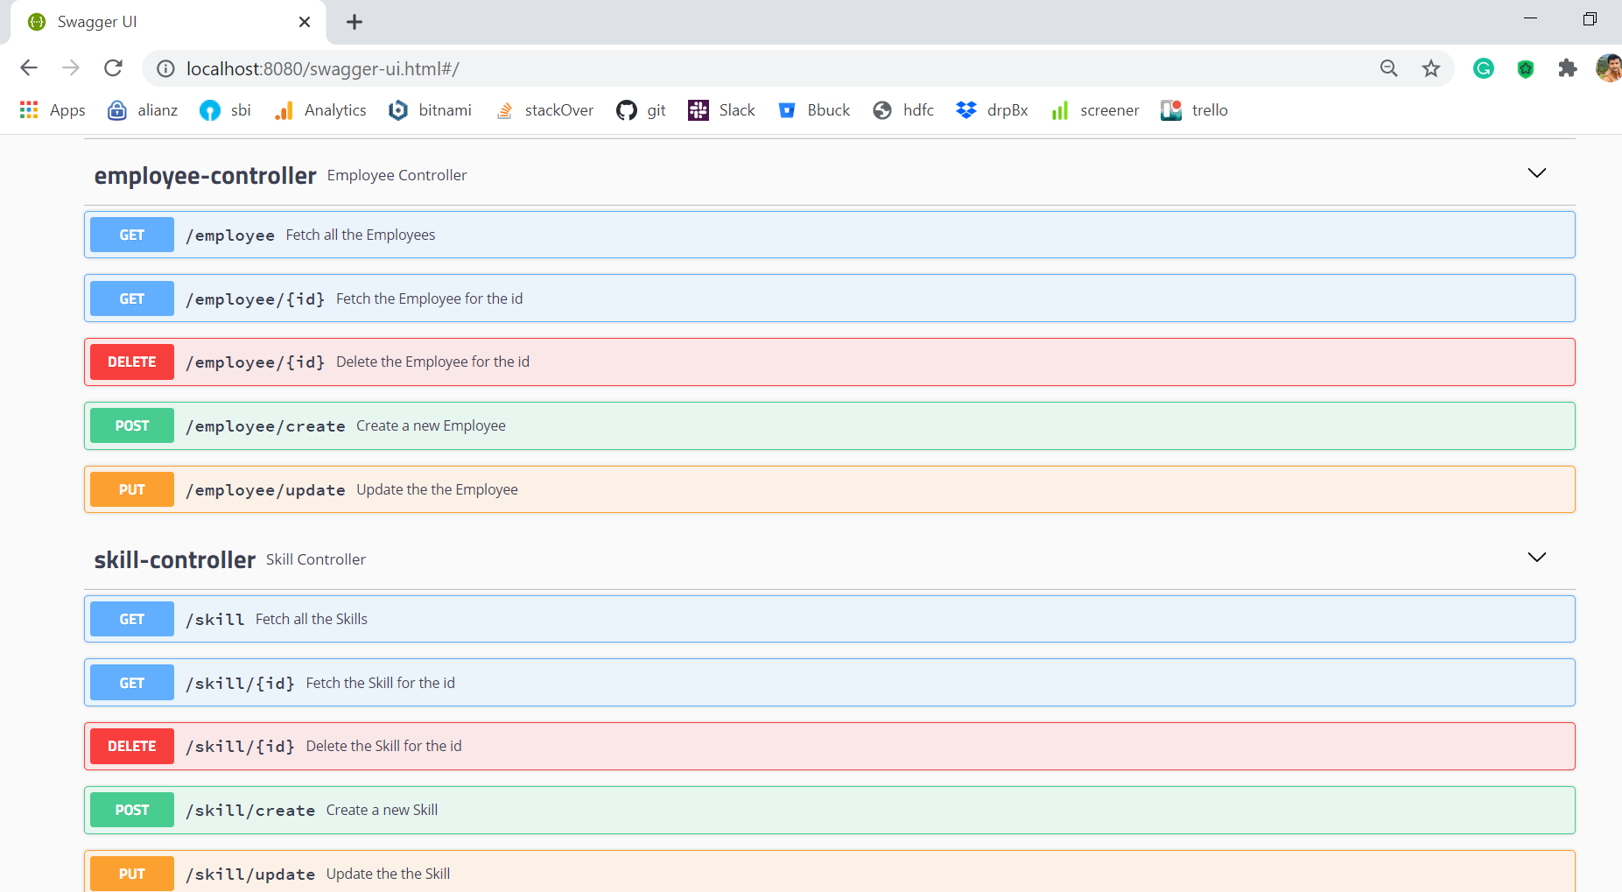

## POSTMAN

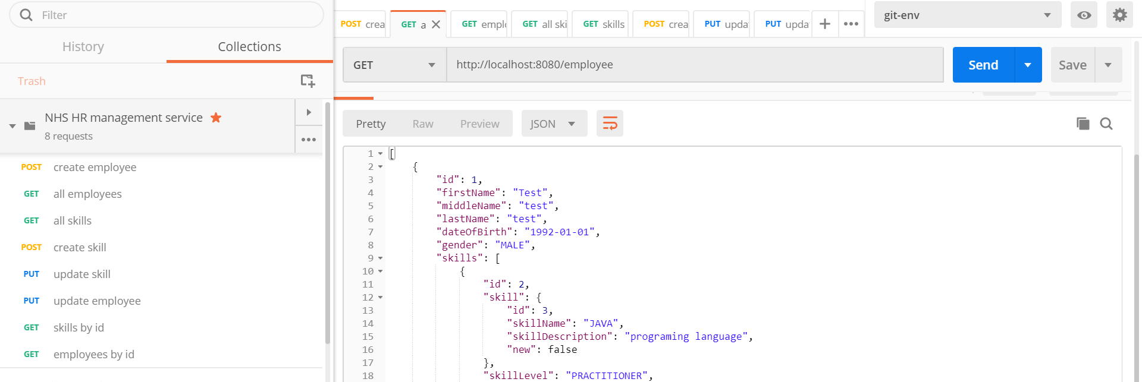

## Database Output

### Employee table

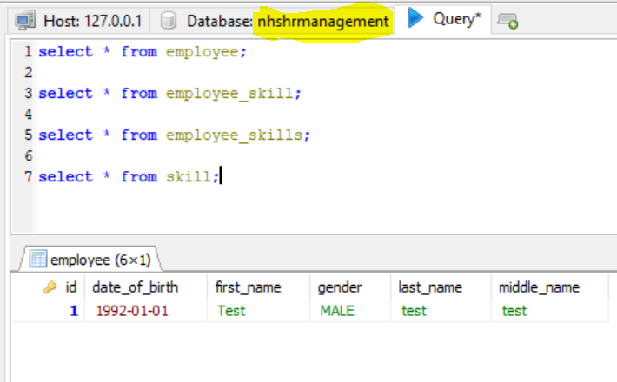

### Skill table

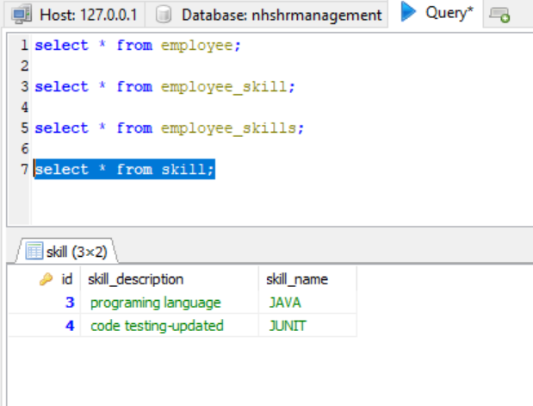

### Employee Skill Table:

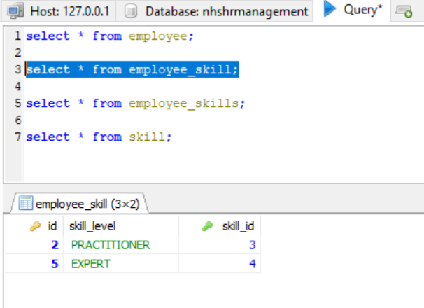

### Employee skill relation table:

